DATE: 11/26/2019
FROM: Kimberly Fanshier
TO: Prof. Andrea Armstrong and Erica Navalance
RE: Better Know a Jail Memo: East Carroll River Bend Detention Center

MEMO

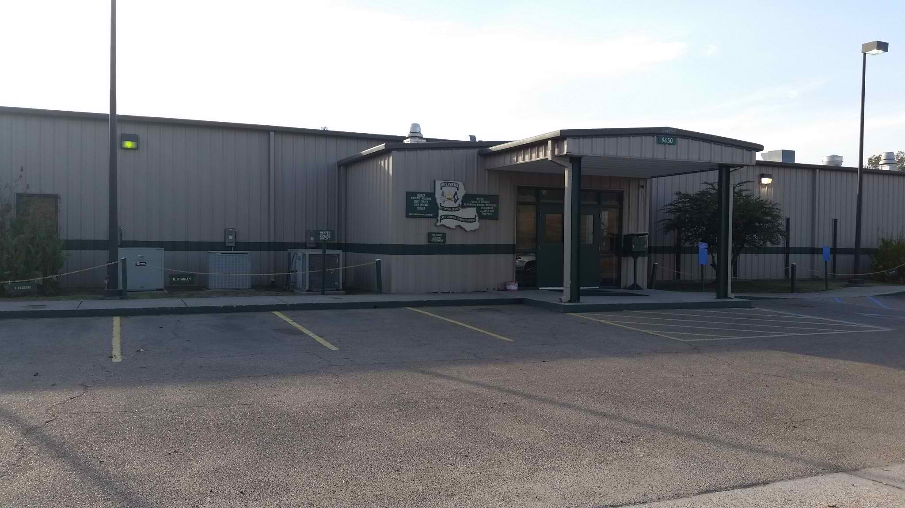
- General Information and Transparency
East Carroll Riverbend Detention Center (ERDC) was built in 1995 in Lake Providence, in the Parish of East Carroll in Northeast Louisiana. It is sometimes spelled River Bend Detention Center and sometimes Riverbend Detention Center. The men’s facility, as well as the facility offices, are located at 9450 Highway 65 S., Lake Providence, Louisiana 71524. The women’s facility is located at 9452 Highway 65 S. Lake Providence, Louisiana 71254. The detention center is currently owned and managed by the parish and Sheriff Wydette Williams. He assumed office in 2012, and his education includes Lake Providence Senior High School (graduating class of 1994) and POST certification from the Louisiana Sheriff’s institute.
The sheriff’s contact page lists a phone number for the facility that does not function. However, the sheriff’s office can be reached by calling 318-559-2800. Other sources provide differing contact info that seems to be ineffective– for instance, the ERDC facebook page lists the phone number: (318) 559-2071, which usually rings and never leads to a voicemail or pick-up. The current wardens of the facility are warden Johnny Hedgemon and assistant warden Edward Knight, although the website for the facility does not list their names or contact information.
The sheriff’s office is in the East Carroll Parish Courthouse, located at 400 First Street in Lake Providence, Louisiana. The distance between the sheriff’s office and the ERDC is 2.1 miles and takes approximately four minutes to drive. Though office addresses for both the detention center and the sheriff are listed, the sheriff’s office does not readily respond to requests by mail. The contact page includes a link presumably for e-mail, but the link is broken. The sheriff’s office does use a fax machine, number 318-559-5983, and requests documents and communications be sent to this number.
The Louisiana Department of Public Safety and Corrections lists another facility, the East Carroll Detention Center, on its current web page for East Carroll Parish detention centers with the address 219 Hollybrook Road, Lake Providence, LA 71254. However, when asked for clarification, the East Carroll Sheriff’s office reported that the ECDC and the ERDC were “the same” and “at the same location.” The phone number listed for ECDC – 318-559-0087 – is disconnected, and no person responded to requests mailed to the listed address or faxed to the fax number provided. Other sources, such as websites for locating inmates and setting up payment portals and communications, such as Pigeonly.com, prisonfinder.org, jail-data.com, and www.nodeathpenalty.org list East Carroll Detention center as “closed.’ However, the East Carroll Sheriff annual financial reports from Louisiana Legislative Auditor in 2018 demarcates separate line items for East Carroll Detention Center and Riverbend Detention Center. Similarly, the East Carroll Parish Assessor’s annual statements from 2014 list the facilities separately, as does a 2011 Legislative Audit of the Louisiana Department of corrections and a 2017 report prepared by the Louisiana Commission on Law Enforcement and Administration of Criminal Justice.
The current population of the facility is not readily apparent. When asked directly, the administrative workers in the sheriff’s office stated that they “did not know” how many inmates were in the facility currently or the present capacity. When asked if the facility held both women and men, they stated that was correct. When asked if the facility held inmates awaiting trial from the parish as well as inmates serving time under the custody of the State of Louisiana Department of Corrections (DOC) and who had sentences, the staff reported that was correct. However, when asked to clarify what percentage of the inmates were DOC inmates, the staff reported they did not have that information. When asked who to contact to discover that information, the staff either hung up or provided a phone number they indicated went to “one of the wardens.” The phone number was 318-559-0942 and rang without answer on multiple occasions.
Although the sheriff’s office made no comment on juveniles when asked about population make-up, a 2019 news article from The Advocate reports that since the East Baton Rouge Sheriff’s office closed its Parish Prison Juvenile wing, the prison has sent youth to the Riverbend Detention Center. The article indicates that of May 2019, there was at least one 15 -year-old and one 17-year-old ordered to remain at the adult jail after other juveniles were removed to another facility pending litigation.
In 2013, Sheriff Wydette Williams regained parish control of the detention center after a short period of private administration using a $16 Million dollar bond from the parish. As part of this deal, Sheriff Williams agreed to use 40 percent of the facility – at that time 160 beds – to house inmates from the Department of Corrections. The goal of that plan was to allow for overflow from overcrowded facilities – especially in Orleans and East Baton Rouge Parishes – and simultaneously provide a source of income for the parish to get out of debt and continue managing the facility and making money from the presence of state inmates. In 2013, therefore, it appears the total number of beds in ERDC was 400.
However, the 2011 report from the Louisiana Commission on Law Enforcement and Administration of Criminal Justice separated the facilities into four categories: East Carroll Detention Center, East Carroll-River Bend Detention Center Phase I, II and III. The report indicates the capacity of the facilities in this table:
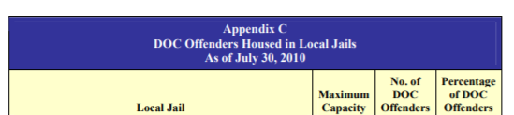
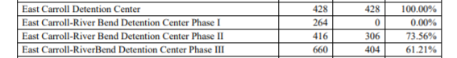
This table seems to indicate that the facilities overall hold a larger number of inmates, and perhaps separate men and women along these lines. As of 2010, it seems the ECDC was still in operation and housed only DOC offenders but seems to now be a campus that is used but falls under the title of ERDC.
Other sources, like Jaildata.com and inmateaid.com list the capacity as ranging from 1,340 beds to 1,362 – which appears to be a sum of the listed capacity of all three “River Bend” facilities on the above table. These sources do not list any demographic info.
The 2017 status on correctional facilities report contains the following table reporting on DOC inmates at ERDC:
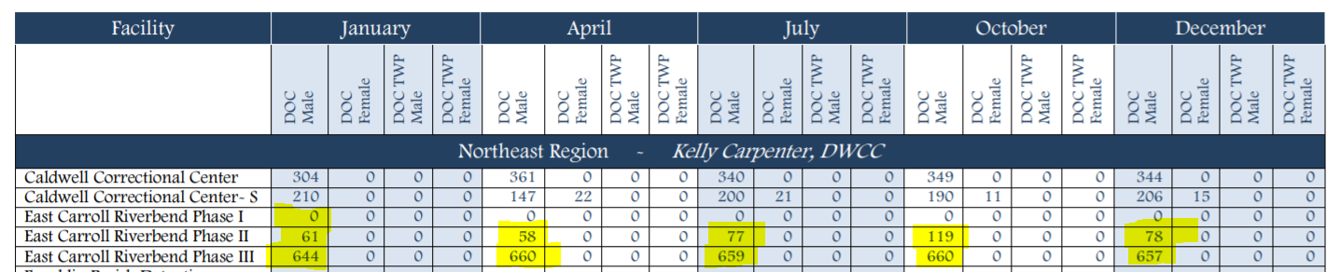
This table seems to indicate that the two Riverbend Facilities have DOC inmate populations ranging between 60 and 120 and 650-660 over the course of a year, and that there are not female DOC inmates. If 735, the number is December of 2017, was 40% of the facility’s entire population per the 2012 arrangement, the population could be as high as 1,850 inmates.
The East Carroll Parish sheriff’s financial statement report from 2018 lists different operating budgets, state of the detention center fund resulting from the 2013 bond, as well as revenue, and commissary funds. Without further expertise in municipal budgetary work it is difficult to parse exactly what the cost of running the facility is or the revenues it garners. However, it seems the yearly budget in fiscal year ending June, 2018 was $9,986,760.
The website “Nodeathpenalty.org” reports that The East Carroll Riverbend Detention Center currently employs over 150 staff members, has an operational infirmary that has two part-time nurses, three full-time nurses, and a part-time doctor. Also, it reports that the facility has a fully operational kitchen where all meals are prepared daily.
The 2017 status of state and local corrections facilities programs report reports that ERDC has minimal programming and services, including “Standardized pre-release curriculum” and “FDIC Money Smart for Young Adults.” The treatment programs listed as being available at the facility are: “Cage your rage,” “Louisiana Risk Management Model,” “Partners in Parenting,” “Thinking for Change,” and “Understanding and Reducing Anger.” The facility management doesn’t readily list other non-state certified programming.
With the confusing names, broken links, changing contact information, non-functioning phone lines and uncooperative staff, combined with the lack of basic information available on the sheriff’s website or with rudimentary internet searches, the facility is not transparent. The office has failed to provide any written response to public records requests sent in August, September, October and November by mail and fax after dozens of phone calls. In addition, staff seems to provide new people and new contact information with every contact made, making it difficult to track communication history. Records requests sent to parish coroners have also gone unanswered.
The sheriff’s budgets from 2011 and 2018 contain independent auditor’s reports. The facility was included in the 2017 Louisiana commission on law enforcement and justice report cited previously, and the facility was included in the 2011 Louisiana Legislative Audit. However, the facility does not appear to have any further audits or certifications, despite recurrent presence in the press for litigation and other concerns regarding conditions and failure to comply with law. The MacArthur Justice Foundation is tracking publicizing news items, reports, and information about the facility as part of its investigations into illegal detentions of individuals.
- Ownership and Control of the Facility
A parish jail named East Carroll Detention Center served as the parish jail since at least the early 1980s, if not earlier, and had transferred from Parish to private control after a period financial and corruption scandals in the 1980s and 1990s.
Constructed in 1995, some sources report that the Riverbend Detention Center initially held 202 beds and was created to deal with overflow from other parish jails. In 2000, the parish expanded the facility to 416 beds, and has apparently expanded beyond that point since.
In 2012, then Sheriff Michael Shumate embarked on a plan to sell the prison to Emerald Prison enterprises, a private prison management firm. However, he was on his way out of office, and the incoming sheriff elect – current Sheriff Wydette Williams – had different plans. He sued the state to stop the contract, and Sixth District Judge John Crigler issued a temporary restraining order preventing the sale. Shortly after a hearing on the matter, the Department of Corrections conducted a “massive shakedown” at the facility, resulting in the discovery of extraordinary amounts of drugs, cellphones, weapons and other contraband and the removal of 350 inmates from the facility. After the removal of these inmates, whom the DOC reported tested “positive” for “drug testing,” 500 inmates still remained at the ERDC facility – indicating higher population counts that other sources previously reported.
At the time, sources reported suspecting Sheriff Williams of arranging the “shakedown” in an attempt to scare Emerald Enterprises from completing their contract – an allegation that Sheriff Williams denied. Upon the judge entered an order to stop the sale. Then, after a year of impending litigation, they settled, stipulating to the deal with Department of Corrections discussed in the previous section. Inmates were being moved in between the closed East Carroll Detention Center and the Riverbend Facility. In the new plan the Riverbend facility would also house inmates awaiting trial from East Baton Rouge and LaFourche parishes.
Sheriff Williams was elected partially on a platform to remove Emerald Enterprises from East Carroll, and stated that keeping the facility in parish control was an incredibly important issue for the parish – maintaining a significant number of jobs, stimulating the economy, and preserving public safety. He is still the sheriff at this time.
- Public Perception and Access
The sheriff’s office website – www.ecsheriff.net/contact - contains links to TouchPay and Securus Tech in a paragraph explaining what to do if you need to get in touch with an inmate at Riverbend. It does not include links to an inmate locator or house its own search service to connect people outside to inmates at the facility.
The facebook page for the facility - https://www.facebook.com/pages/East-Carroll-Riverbend-Detention-Center/260685300629255 – contains several statements from family members of individuals housed there requesting information about how to reach their loved one who was recently moved from another facility. It also contains several reports of poor conditions, refusal of visitation, refusal to provide access to legal documents, refusal of medical care, brutality and violence of staff toward inmates, and other complaints. Other forums for inmate location and aid contain similar questions and complaints.
Conversely, the East Carroll Sheriff’s department Facebook page shows the sheriff and deputies involved in many community events and shows engagement and support from local community members.
There were articles detailing the parish sale and re-purchase of the facility in 2012 and 2013. Since then, there have been articles surrounding litigation involving the facility – the detention of juveniles, prisons conditions, and the unlawful detention of at least five and as many as 100 inmates for months after their actual release dates. There was also news reporting on two inmates who escaped the facility in September, 2019, and were located and returned to the facility weeks later.
Without any response from the facility or sheriff’s office, it is unclear whether there have been any deaths at the center in the past five years. However, there is not any readily available reporting on deaths that could have occurred there, which would probably be mentioned in the reports surrounding litigation.
- Litigation
In addition to the lawsuits surrounding the jail’s ownership, the facility has been the focus of several claims in the past 20 years. There have been prisons conditions suits alleging Eighth amendment violations in the 1990s and 2008, both of which were denied for failure to state a claim. One claim, Herman v. Holiday, alleged a variety of deficiencies in living conditions at the East Carroll Detention Center. More specifically, Herman claimed that he was deprived of adequate clothing and exposed to asbestos and pesticides which could result in future health problems. He also complained that the Detention Center was mosquito infested and located near an open cesspool, that there was insufficient hot water for bathing or washing dishes, that eating utensils were not properly sanitized, and that food was cold. The case resulted in an important discussion of proper service to an inmate, however, the claims failed to surpass a motion for summary judgment.
Throughout the 2000s, there were dozens of similar claims brought against ERDC, East Carroll Sheriff’s office, Emerald Correctional Facilities and East Carroll Parish alleging procedural and substantive due process violations, denial of medical care, refusal to allow visitation or temporary release for funerals of parents, harsh treatment, and exposure to violence from fellow inmates and staff. None seem to have moved beyond a 12(b)(6) motion from the defendants.
In 2017, attorneys from the MacArthur Justice Center sued the Sheriff and the facility in two separate suits after discovering that five inmates were held for several months past their release dates. The plaintiffs are seeking unspecified monetary damages for state tort claims including false imprisonment and intentional infliction of emotional distress as well as civil rights claims. The attorneys claim that in addition to the current plaintiffs, hundreds of other inmates are likely being held in ERDC well past their release dates. Also, another civil rights claim was filed in October by another inmate alleging eighth amendment violations.
- Parish History
East Carroll parish is extremely rural – the town of Lake Providence has just over half the population it had in 1880 (7,037 today as opposed to around 13,000 In the 1880s). The parish reached a peak population of almost 20,000 people in 1940, but maintained about 12-13k from the mid 19th through the later 20th century, until a rapid down turn in the past two decades. Just after the civil war, the almost completely agricultural area had a majority population of African American farmers. Those farmers formed a parish government and elected sheriffs, magistrates, and all other government officials from the community, and gained a sizable amount of political power in the region. However, this was disrupted by white settlers who, distressed at the rise of African-American political power and control of property, led a years long campaign of violent harassment, and eventually split the geographical region to create the majority white West Carroll Parish.
Lake Providence and East Carroll Parish are still economically depressed communities. In 1994, Lake Providence was featured in Times Magazine as the “poorest community in America.” In 2013, CNN published a story describing Lake Providence as the “most unequal place in America,” and the poverty rate exceeds 50%.
The highway where the facility sits is slightly outside of town in the middle of still-present agricultural fields, less than a mile from the banks of the Mississippi river and the state line. It neighbors a Pentecostal Church, a gas station, and a tractor store.

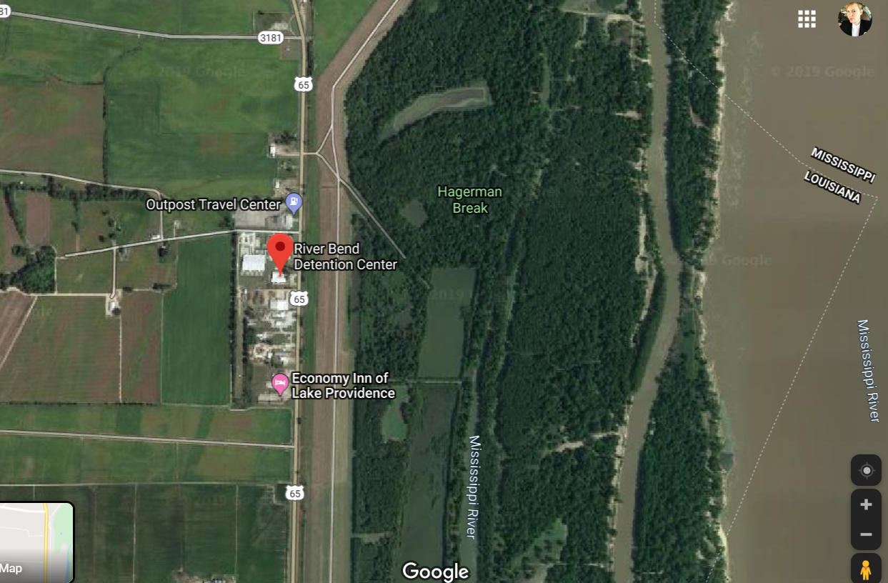

“River Bend Detention Center,” Jail Data, https://www.jaildata.com/prison/east-carroll-parish-river-bend-detention-center-rbdc.
East Carroll Sheriff’s Office contact page, https://www.ecsheriff.com/contact.php.
Louisiana Department of Public Safety and Corrections, “East Carroll Parish” https://doc.louisiana.gov/location/east_carroll_parish/.
https://www.ecsheriff.com/contact.php.
Id.
Crittendon v. Gusman, Case No. 3:17-cv-00512-SDD-EWD, First Amended Complaint, http://nofba.org/wp-content/uploads/2017.08.31-4-First-Amended-Complaint.pdf.
Id.
Id.
https://doc.louisiana.gov/location/east_carroll_parish/
Phone conversation with administrative staff of sheriff’s office.
East Carroll Sheriff Annual Financial Statements with Independent Auditor’s report 2018;
https://www.lla.la.gov/PublicReports.nsf/9303CAA9AAD2EBF986257E0A00544232/$FILE/0000673B.pdf
https://lla.la.gov/PublicReports.nsf/A7AD417DC50C45F78625781000567F69/$FILE/0001B4AF.pdf
http://lcle.la.gov/programs/uploads/2017_Status_of_State_and_Local_Corrections_Facilities_and_Program_Report.pdf
Phone calls, 11/14/2019, 11/20/2019, 11/22/2019.
Id.
Id.
Id.
Toohey, Grace. “Baton Rouge Judge to make ‘precedent’ ruling on pre-trial detention of youth facing serious crimes,” The Advocate, May 27, 2019, https://www.theadvocate.com/baton_rouge/news/courts/article_dc1c5f8a-7d91-11e9-a9dc-5f867839a255.html.
Id.
East Carroll Parish Sheriff Annual Financial Statements, 2019 https://app.lla.state.la.us/PublicReports.nsf/B757C8E0CA002FD8862583DD0077E101/$FILE/0001C77C.pdf, p. 39.
“East carroll parish buying private prison,” The News Star, Associated Press, November 22, 2013.
Id.
Id.
https://lla.la.gov/PublicReports.nsf/A7AD417DC50C45F78625781000567F69/$FILE/0001B4AF.pdf p. 49.
Id.
https://www.jaildata.com/prison/east-carroll-parish-river-bend-detention-center-rbdc
https://www.inmateaid.com/prisons/east-carroll-river-bend-detention-center-rbdc.
https://app.lla.state.la.us/PublicReports.nsf/B757C8E0CA002FD8862583DD0077E101/$FILE/0001C77C.pdf, p. 45.
http://lcle.la.gov/programs/uploads/2017_Status_of_State_and_Local_Corrections_Facilities_and_Program_Report.pdf p. 76.
Id at 82.
Matthews, Jeffery G. Holding Accountants Accountable: How Professional Standards can Lead to Personal Liability. Wiley, p. 142.
https://www.jaildata.com/prison/east-carroll-parish-river-bend-detention-center-rbdc
Id.
“Judge Issues Order preventing Jail sale”, The News Star, Associated Press, February 10, 2012 and August 27, 2012.
Id.
Id.
Id.
Id.
Id.
Id.
https://www.facebook.com/pages/East-Carroll-Riverbend-Detention-Center/260685300629255
https://www.facebook.com/ecsheriff/
https://www.nola.com/news/crime_police/article_969c5f74-e32d-56d7-adc4-55c591d85998.html
https://www.knoe.com/content/news/two-men--561005211.html
Herman v. Holiday, 238 F.3d 660 (La. Ct. App. 2001).
Id.
E.g. https://www.casemine.com/judgement/us/5914ec00add7b04934947153
https://www.nola.com/news/crime_police/article_969c5f74-e32d-56d7-adc4-55c591d85998.html
http://nofba.org/wp-content/uploads/2017.08.31-4-First-Amended-Complaint.pdf, https://www.nola.com/article_b8ba155b-17f9-5b1c-a7af-462cf3af2e05.html
https://www.nola.com/news/crime_police/article_969c5f74-e32d-56d7-adc4-55c591d85998.html; https://www.theadvocate.com/baton_rouge/news/courts/article_dc1c5f8a-7d91-11e9-a9dc-5f867839a255.html; https://www.macarthurjustice.org/case/copelin-v-gusman/
https://dockets.justia.com/docket/louisiana/lawdce/6:2019cv01282/170978
http://worldpopulationreview.com/us-counties/la/east-carroll-parish-population/
Id.
Matthews, Jeffery G. Holding Accountants Accountable: How Professional Standards can Lead to Personal Liability. Wiley, p. 142.
Id.
https://www.thenewsstar.com/story/news/2019/08/29/louisianas-poorest-place-america-gets-economic-boost-lake-providence-john-bel-edwards/2150521001/
Id.

